Welcome to AS and A level Business!
Year 11 students intending to study A level business, 2021-2
Dear Students
Thank you for choosing Business! Here is some information for you, plus, a tasks, a project, and activities/reading list to get you off to a great start! Business is a very popular subject at English Martyrs – you are in great company! We love Business – and hope you will too!
Famous Business people
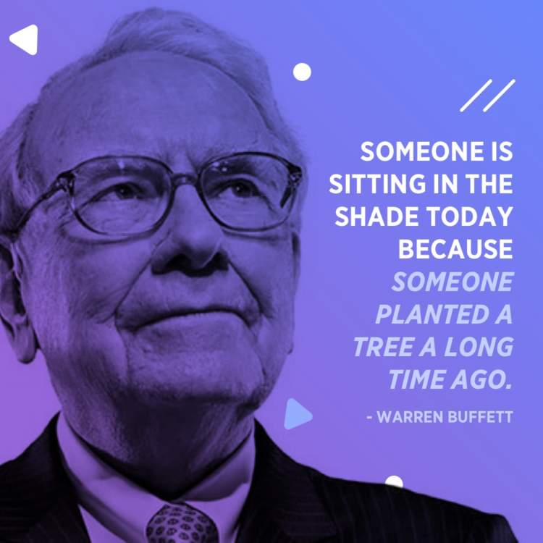
Warren Edward Buffett is an American business tycoon. He has a net worth of over US$85.6 billion as of December 2020, making him the world's fourth-wealthiest person.
He’s also a notable philanthropist, as is Bill Gates (co-founder of Microsoft and for many years the wealthiest person in the world); having pledged to give away 99 percent of his fortune to good causes, primarily via the Bill & Melinda Gates Foundation.
Mr Buffett developed an interest in business in his youth, and later graduated from Columbia Business School.
We cannot guarantee you will become a billionaire!
But, what better place to start than by studying A Level Business at English Martyrs’ Catholic School?
Price is what you pay; Value is what you get
This quote from Warren Buffet sums up what we in Business believe.
- If you choose A level Business, you will need to be good.
- You’ll work hard, and you’ll enjoy it.
- But value is all about getting what you pay for. And that means an A level that works for you in return.
We say this because A level Business opens doors. Here’s what some current and past A level Business students say:
“Business is the most beneficial, flexible, interesting, and useful subject on any curriculum and the opportunities that come with this course are almost limitless, and you don't want to limit yourself, do you? “ Ashin
“I have found that business has opened my eyes to the real world and real-life events. It has opened many doors and is setting me up for the future”. Megan
“You gain experience for life in general, along with developing business skills, which is really good as it will be valuable no matter what you choose to do post-A levels”. SN, Year 13 2019-20, now studying Accountancy at Loughborough University.
What’s on the course?
Year 12 – AS Business
1 What is business?
2 Managers, leadership and decision making
3 Decision making: marketing
4 Decision making: operational performance
5 Decision making: financial performance
6 Decision making: human resource performance
Year 13 – A2 Business
7 Analysing the strategic position of a business
8 Choosing strategic direction
9 Strategic methods: how to pursue strategies
10 Managing strategic change
Exams!
There are two papers at the end of Year 12 and three papers at the end of Year 13.
Each paper covers all aspects of the Business course that you have studied that year.
We teach exam technique from the very start of your course, and you will receive plenty of practice and feedback to enable you be confident and do well in all exams. You will know what to expect on each paper.
So let’s get started!
The text book – order now if you want to be organised!
You will only need one text book and it is in the School shop (other outlets are available!). We also recommend the CGP Revision guide, also in the shop. Exam board is AQA.
AS & A Level Business Revision and Practice for AQA | AQA Business for AS and A level
ISBN 9781782943518 | ISBN 9781510453340
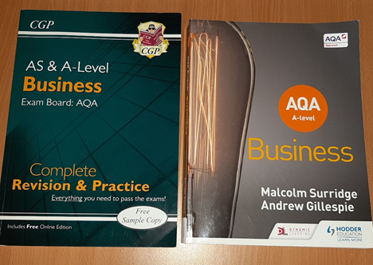

All students are given FREE booklets that have been created by your Business Teachers covering the specification of the Course and every lesson has an accompanying PowerPoint which are available to students as well.
GCSE Business
Do not worry if you have not studied Business at GCSE! We teach the Business A level independently of the GCSE, so it does not matter if you are new to Business.
We provide booklets to our GCSE students and every Year 12 student of Business will be given two of these to read through and answer some questions to give everyone the best possible start to the course. Those of you who have done GCSE will find this useful revision!
See Task 3 below.
How can I prepare to be the best Business student that I can be?
The transition from GCSEs to A Levels can be a big one for all students, but you can do several things to ensure that the transition is as easy as possible:

1. Be organised! The more organised you are, the less time you will waste – helping you make the most of your time and feeling more confident, ready to do well! So:
a) Get hold of an A4 folder and some dividers; bring these to every lesson.
b) Place notes and resources on each topic in a section. Use the topic headings above.
c) Have a section at the end for assessments and additional information such as the business models list.
2. Attendance – You must attend all lessons as each and every lesson will cover exam content. A missed lesson means you must catch up. Let your teacher know if you cannot attend. It is your responsibility to do any work you have missed. Your teacher will help if you are not sure what you need to do.
3. Independent study – Just attending all your lessons will not be enough. You must commit to 5 hours independent study per week. This will involve homework completion, reading, compilation of revision notes etc.
4. Complete the work set and meet all deadlines – make sure you do the work that your teacher asks you to do right from the start. This will prevent you from falling behind and you will learn effectively throughout the course. This includes homework!
Useful reading and other activities to help you succeed in Business!
- https://www.forbes.com/lists/global2000/#2a45d91a5ac0
- https://www.bbc.co.uk/news/business
- https://www.theguardian.com/uk/business
- https://inews.co.uk/category/news/business
- https://www.businessinsider.com/?IR=C
- https://www.entrepreneur.com/
- Listen to Radio 5 live for the business news
- The Financial Times newspaper

Task 1
INTERESTING TIMES! Your Business Project

There is a Chinese curse which says “May he live in interesting times.” Like it or not, we live in interesting times. They are times of danger and uncertainty; but they are also the most creative of any time in the history of mankind!
So, it is time for you to find out more about businesses in interesting times!
Where did the Coronavirus come from? There have been various suggestions: but currently, we do not really know. However, it is likely that the virus emerged naturally and became stronger due to natural selection. And it could well have originated in China. Interesting times indeed!
As business students we could argue that businesses emerge naturally and grow stronger too! But like the virus, they can be defeated or become even more effective over time. So, there has never been a better time to need to look at how businesses will cope in interesting times.
Your Business Project is to research and create a report on how the current Coronavirus pandemic is affecting British businesses. The report should be detailed and written in good English! You can refer to other countries, but try to focus on the UK.
The report should ideally be created electronically, but it can be hand-written if you do not have access to a computer. Illustrate your report with graphs, photographs, charts and so on. Always list your sources!
The report should include the following:
3) Introduction: Background to the situation
A general comment on how the virus will affect people and thereby, businesses. For example, people in the UK are not able to leave their homes, unless they are 1) essentially working 2) shopping for food or medical supplies 3) taking brief exercise.
So how has this affected businesses? Which are affected the most? How are they affected, precisely? Have any businesses benefited from the situation?
2) Focus on one business (or industry)
Then choose ONE particular business and research how they are coping and likely to cope during the crisis. What are they doing to alleviate the situation? Are they looking after their workers? Selling online? This could be an airline, a retailer, a restaurant chain…. It would be best if you choose a business that is actively working to lessen the impact longer term, rather than one that has just collapsed! Or you could talk about small businesses. What is it about your chosen business, that would help it to succeed?
3) Finally, a conclusion, summarising the situation for your chosen business (or industry) and if you can, assessing how the British economy will cope short, medium and long term.
You should show some judgement here. E.g. based on the evidence, what do you think the long-term effects will be? Will this differ across the world?
4) Bibliography: a list of where you obtained your information. This can be internet, newspapers, television reports….
We hope that you will enjoy this project, and it could be useful to you in so many ways, e.g. it will help to inform your 6th form studies, be aware of the issues caused by crisis, even help you to choose your future career!
Your deadline for submission is the first Business lesson in the new academic year!
If you have any questions, please e mail Mrs Westwood Dickens or Mr Hunt.
awestwooddickens@englishmartyrs.org
ahunt@englishmartyrs.org
Here are some links to help you:
https://www.icaew.com/technical/business-and-management/strategy-risk-and-innovation/risk-management/coping-with-coronavirus
https://www.economist.com/coronavirus-pandemic
https://www.economist.com/graphic-detail/2020/04/17/coronavirus-infections-have-peaked-in-much-of-the-rich-world
https://www.economist.com/leaders/2020/04/08/the-coronavirus-crisis-will-change-the-world-of-commerce
https://www.independent.co.uk/news/uk/home-news/coronavirus-lockdown-job-losses-unemployment-recession-university-essex-study-a9472966.html
https://www.theguardian.com/business/2020/apr/09/us-unemployment-filings-coronavirus
https://www.bbc.co.uk/news/business-51706225
https://www.theguardian.com/business/series/guardian-business-live
https://www.telegraph.co.uk/business/covid-small-business-self-employed-start-ups-coronavirus/
TASK 2
There are a lot of models in A level Business, they are listed below. Some are studied in Year 12, some in Year 13. The three year 13 papers can ask you about ANY of these models – it is essential that you know them! So this task will give you a great head start.
Research each model and make notes. Draw the model. Find out business examples of where they have been used.
Useful links include
https://www.tutor2u.net/business/collections/aqa-a-level-theories-models
https://filestore.aqa.org.uk/resources/business/AQA-7131-7132-TG-MTF-HB.PDF
AS AND A LEVEL MODELS
MODEL | Use for | SHORT CUNNING PHRASE
Elkington’s Triple Bottom Line | Discussing objectives; CSR and social environment; what factors affect the setting of business objectives. | Links different business objectives, not just profit, with sustainability.
Kotter and Schlesinger’s Model for overcoming resistance to change | Reasons for change, significance of change, why resistance may exist. | No one likes change; 6 approaches to overcoming this problem.
Kotter and Schlesinger’s reasons for resistance to change | Which motive for resistance is important; how to overcome (see K&S above) | 4 types of reason why people resist change.
Tannenbaum Schmidt Continuum | Advantages and disadvantages of different approaches in certain situations. Need to change according to requirement. | Highlights management styles adopted, along a continuum from authority to freedom.
Bartlett and Ghoshal’s International, Multi-domestic, Transnational and Global strategies | When discussing international businesses and the best strategy to adopt overseas. Depends on market conditions. | 2 key factors affecting approach to multinational business: local market pressures, and cost savings from global integration.
Greiner’s Model of Growth | Analysing change and growth, how structures change, (de)- centralisation | Shows 5 stages of growth and crisis points that happen as organisations grow and age.
Hofstede’s National Cultures | Use principles for differing business cultures which could cause clashes e.g. in a merger, entering overseas markets. | Different forms of national cultural differences.
Kaplan and Norton’s balanced scorecard | Holistic view based on perspectives: Financial, customer, internal business process, learning and growth. | Looks at the existing internal position of a business to assess strengths and weaknesses, not just related to profit.
Bowman’s strategic clock | Plot strategies and assess their effectiveness. Link with Porter’s strategies. How businesses improve their competitiveness. | Different strategies in terms of perceived benefits: perceived added value, and price.
Blake Moulton Grid | Advantages and disadvantages of each approach; factors that determine which style is used. | Highlights different management styles according to concern for the task itself and concern for the people who do it.
Hackman and Oldham Model of Job Design | Look at the different aspects of a job, link motivational theories. | 5 aspects of job design that influence how motivating it is and impact on performance.
Handy’s Culture | How will the culture impact on functions & ability to meet objectives. | 4 types of culture. Power, role, task, person.
Ansoff’s Matrix | The degree of risk associated with the chosen strategy. Will this help the business achieve its objectives? | The degree of risk vs. potential reward for strategic options based on whether market and/or product are new or existing.
Porter’s Generic Strategies | Consider whether the adopted or proposed strategy is likely to give a business competitive advantage. | 4 strategies that could be adopted to gain competitive advantage, in mass or niche markets, based on either cost leadership or product differentiation.
Porter’s Five Forces of Competitive Position | Consider the market the business is in. How do the forces impact. Does the business benefit from any of them? | Assesses the competitive environment; helps businesses to analyse their position in a market.
Boston Product Matrix | Importance of a balanced portfolio. Link to product life cycle. | Product Portfolio analysis model. Products’ positions depend on market share and market growth.
Maslow’s Hierarchy of Needs motivational theory | Analysing if an employee is likely to be motivated in a certain way. | Levels of psychological human needs applied to work situations. Each must be achieved before a person can move up to the next level.
Taylor’s Scientific Management motivation theory | Nature of job, skills of workforce. Effectiveness of financial (monetary) incentives. Will this achieve org. objectives? | Man is motivated by money. Time and motion study measures time taken and actions used to complete tasks. Linked to specialisation, piece work, monetary rewards.
Herzberg’s Dual (Two) Factor MotivationTheory | Consider whether the factors are present, how will they impact, link to management styles. | Two factors: hygiene (do not motivate but cause dissatisfaction if removed) and motivating factors. Hygiene = surrounding the job e.g. pay, conditions. Motivating = achievement, the work itself, promotion etc.
Lewin’s Force Field Analysis | Change may be driven through if forces against lessen, or driving forces increase. How to alter these forces. | How to bring about change, given forces for, and obstacles against, change.
Decision trees | Decide between options. Value of decision trees, limitations, extent to which values can be assigned accurately. | Scientific decision making shows expected value and net gain of alternative decisions using figures.
Stakeholder mapping | Assess factors that affect relative power and influence of stakeholder groups. How businesses may treat them, and how stakeholders could increase their power. | Categorises stakeholders in terms of their power and their interest.
Market mapping | To show different criteria customers may use to assess products, how a business could position a product, why change its position. | Graphical model showing customer perception of different products/brands in a market.
Income elasticity of demand | How responsive demand is to change in income; correlation | YED (IED) = % change in quantity demanded ÷ % change in income
Price elasticity of demand | How responsive demand is to change in price | PED = % change in quantity demanded ÷ % change in price
STP: segmentation, targeting, positioning | See how markets are segmented, what makes segments attractive, positioning of the product (link with market mapping), marketing mix | Outlines the marketing process.
7 Ps of the marketing mix | Link with product life cycle and other aspects of marketing. 7Ps must be appropriate for the product and link with each other. | Different aspects of marketing a business may manipulate to achieve objectives for a product over time.
Inventory (stock) control chart | What happens if usage is faster than normal? What if inventory is too high or too low? | Graph showing stock level over time; issues such as max. stock level, re-order quantity, buffer stock, lead time.
Carroll’s Corporate Social Responsibility pyramid | State of economy: effect on business priorities. Link to objectives, stakeholders. Implications of these choices. | 4 aspects of CSR: Economic, legal, ethical, philanthropic. It is not just about doing the minimum.
Strategic drift | Managers must continually review strategies to remain competitive and relevant. Importance of preparing for and reacting to change. | Strategy pursued by a business no longer fits its changing environment.
Business Cycle | Link to PED and YED. Effect on supply and demand. | Graph, showing fluctuations in level of economic activity, compares GDP level over time.
Product life cycle | Assess the marketing mix that could be used to achieve objectives according to the stage in the plc the product has reached. | Shows the stages a product goes through in terms of sales over time.
SWOT analysis | Part of strategic planning process. Be aware that SWOT changes over time. | Assessment of strengths and weaknesses (internal), opportunities and threats (external)
AIDA | Assessing promotional activity.  Attention, interest, desire, action (usually to purchase!). | Marketing model, stages a promotion may go through.

Task 3
At the taster sessions, we are going to give you two GCSE Business booklets. These contain useful information that you will find helpful at A level. So whether you have or have not studied GCSE business, we would like you to use these booklets to answer the following questions. If you are unable to attend the taster lessons please e mail awestwooddickens@englishmartyrs.org and I will send you the booklets.
Booklet: Business in the Real World External Influences
Topic | Questions | Topic | Questions
1.1 | 1-10 | 1.10 | Page 8
1.2 | 1-10 | 1.10 | Page 15
1.3 | 1-10 | 1.10 | Page 20
1.4 | 1-10 | 1.10 | Page 24
1.6 | 1-10 | 1.7 | Page 28
1.7 | 1-10

Please let your teacher have the work when you return in the new Academic year.
A final comment from one of our current A level students…..
I chose business as a last-minute decision, I knew people who had done GCSE business and they seemed alright with it however I did not know a thing about business studies so felt like I was entering unchartered territory. I didn't know whether I was going to like it or not, whether it was going to be easy or hard or whether it was going to be heavy or light. I really did not need to worry, as picking business was one of the best decisions I have made. Business is very interesting as it opens your eyes into how businesses around the world operate and why they may do things such as create apps. Business is also easy to understand as you can easily apply it to real life. The maths in business is not hard either, it is just simple equations so no matter what set you come from there is no need to worry. The content is quite a lot but as mentioned earlier it is not difficult to understand. The mock exam I have sat was not bad either, as long as you know and understand the theory you will get a good grade. I really enjoy my business lessons and would encourage those who have never done business to try it. Isabel, current A level Business student (2020-1).

And a final word from our friend Warren Buffet…….
“The greatest investment a young person can make is in their own education, in their own mind. Because money comes and goes. Relationships come and go. But what you learn once stays with you forever.”
We hope that you enjoy your time studying Business.
Remember: we are always here to support, motivate, listen, and advise…… just get in touch!

