ICT Preparation Project

Social Media in Business Tasks:

Activity 1
Create a report to explain the different ways in which a business can use social media. You may use the Internet to research the various ways a business can use social media however any information used must be in your own words and not copied/pasted. You must also give examples and discuss personal experiences. ​

Activity 2
Create a report explaining the audience profiles of different social media websites. ​ You must research audience profiles (users) for a number of popular social networking websites. You may research the Internet to find this information. If any information is used from the Internet, you must reference it. You must not copy/paste. You must also give examples and discuss personal experiences. ​

Activity 3
Create a report evaluating the business use of social media to interact with customers and promote products or services to a target audience.​ You must consider the features available on social media to interact with customers. Discuss the advantages and disadvantages for them and give your own opinion.​
You must also consider the features available on social media to promote products. Discuss the advantages and disadvantages for them and give your own opinion.​
​Finally must make appropriate suggestions on how the use of social media could be improved in the future.​

Database Tasks:

Activity 1
Databases are made up of records which are like electronic cards. A record contains the information about one particular person or thing. Every record has a similar style, but contains different data.
A field stores a particular kind of data, such as a person’s name, date of birth or even their favourite type of music.
A record is made up of several fields. A group of records that have something in common is called a file.
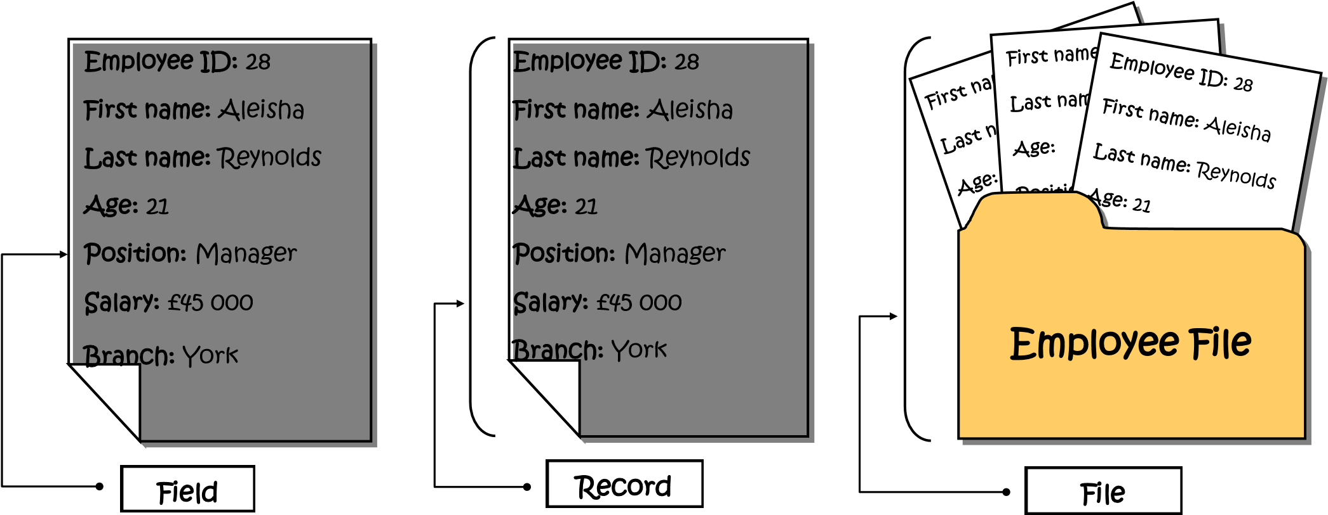

Study the diagram above and answer the questions that follow.

Field name | First name
Data | Aleisha
a]. In the table below list all the fields and data for the ‘Aleisha Reynolds’ record. The first one has been done for you.

b]. How many records are in the ‘Employee File’ above? Tick the correct answer.
one | five | three | none

c]. How many fields are in the ‘Employee File’ above? Tick the correct answer.
five | three | none

Activity 2
Study the database table below in which the Esther Snyder record, First name field and Age field name have all been highlighted.
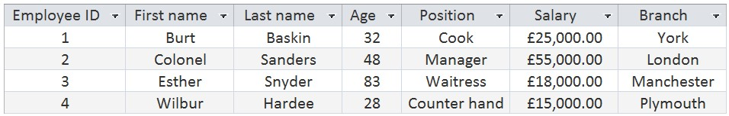

First name field

Field name

Esther
Snyder

record

In the database table below shade, highlight or colour the Burt Baskin record, Position field and the Branch field name.

Read the statement below and then place a tick in the correct box.
 | True | False
The horizontal rows in a database table are called records.
The vertical columns in a database table are called files.

Activity 3
Add the correct labels to the database table below.

Angelo owns an Italian restaurant and has created a database to store information about the orders he takes from his customers. When entering data into a database it is important that it is accurate as any mistakes may cause problems later on when you want to run a search for a particular item.
Study the database table below and identify four [4] mistakes he has made while entering data about the orders. Shade, highlight or colour each mistake.
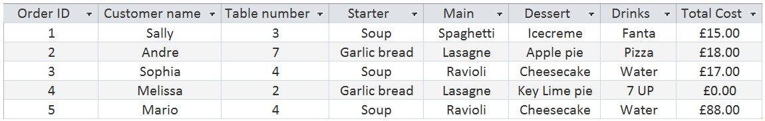

In the spaces below write down what the actual mistake is in Angelo’s database table and then briefly explain the mistake.

a]. Mistake number 1:
Explanation of mistake:

b]. Mistake number 2:
Explanation of mistake:

c]. Mistake number 3:
Explanation of mistake:
d]. Mistake number 4:
Explanation of mistake:

Activity 4
For each field in a database you need to state a data type, that is the format you want for the data. The data type can be short text (alphanumeric), number, date and/or time or currency as well as many other types. Different data types are used for different reasons and need to be chosen carefully. For example, for a person’s name which is made up solely of letters, you need to specify short text as the data type.
Complete the table below.
First add all the field names from the employee card below.
Then fill out the correct data types from the following list:
- short text
- date/time
- autonumber
- number and currency
Field name | Data Type

Activity 5
Look at the data items below and then place a tick next to the correct data type.
 | short text | number | currency
Customer’s email address [me@imail.com]
Customer’s mobile number [123477892]
Cost of burger and fries [£15.00]

Below you have been given the names of some organizations that use databases.
Fill in four [4] field names for each place. The first one has been done for you.
Organizations |  | Field names
Library | Book ID | Title of book | Author | Genre
Video game store
Police Station
Toy Shop

Activity 6
Task Scenario
You have been asked to create a database for an organisation called ‘Get Our Beaches Clean’. The organisation is managed by a small group of volunteers. These volunteers review all of the beaches every year.

The database will record information about:
• the beaches
• the volunteers
• the yearly reviews.

Beaches are categorised by their type, e.g. sandy.
The number of times a beach has been cleaned during the year is recorded.
A volunteer may be assigned to one or more districts, e.g. Boroughside.
A district has only one volunteer.
A beach has a cleanliness rating of at least 1 and a maximum of 3. 1 is the best rating.
Your task is to look at the data extract below and design the 3 tables. List the field names and data types for each.

